

***Punjab University College of Information Technology***

Pick and Drop Services

For Female Students

**SUBMITTED TO**

Ma’am Amina Mirza

**SUBMITTED BY**

BSEF19M006 – Muhammad Adil

BSEF19M043 – Abubakar Dar

BSEF19M053 – Haris Amir



**Supplementary Specifications**

**Revision History**

|  |  |  |  |
| --- | --- | --- | --- |
| version | Date | Description | Author |
| Inception Draft | 11-Nov-2021 | First Draft .To be refined primarily during the elaboration phase. | Muhammad Adil |
|  |  |  |  |

**Introduction**

**Vision**

**Motive:-**

“Your Child’s security is our priority”.

**Description:-**

We envision to create an environment that is safe for female students and provide them with a secure as well as affordable Pick & Drop service in Pakistan.

As parents are busy with their jobs and have no time to pick up and drop their children, we are providing them with this facility at economical cost.

**Scope**

First of all we will analyse tasks and produce minimal required project management documentation: estimates, list of risks and milestones chart based on which we will be able to agree on the final scope of the project. We will focus, for now,on making modules for registration ,authentication ,payment ,pick and drop.

**Functionality**

**Manager:**

* System shall allow the manager to add a new driver.
* System shall allow the manager to add new students.
* System shall allow managers to manage the salaries of staff.
* System shall allow managers to see the current locations of drivers.
* System shall allow the manager to locate the required student.
* System shall allow the manager to contact any active driver.
* System shall allow the manager to view the schedule of every driver.
* System shall allow the manager to login using credentials.

**Parent:**

* The system shall allow parents to locate her student location.
* The system shall allow parents to see the current location of the driver.
* The system shall allow parents to cancel their membership at any time.
* The system shall allow parents to login using credentials.

**Student:**

* System shall assign a unique membership number ,id to the student.
* System shall allow students to login using credentials.
* The system shall allow students to see the current location of the driver.
* The system shall allow students to cancel their membership at any time.

**Driver:**

* The system shall allow the driver to view the list of pickup points.
* The system shall allow drivers to collect their salary online.
* The system shall allow the driver to notify the system on emergency leaving.
* the system shall replace absent drivers with the present one.

**Cashier:**

* The system shall allow cashiers to withdraw cash.
* the system shall allow cashiers to insert cash in digital form.

**Security**

* The system security is divided into confidentiality and integrity.
* To cover confidential information its important to achieve authentication.
* Manger ,Cashier, Students, Drivers are required to login providing username and password.
* Each user will have its own access to data .
* To cover integrity validation of data is required.Data should be consistent.
* Pick and drop points should be exact.
* No unauthorized driver is allowed to use the system.

**Usability**

* The usability goal is divided into following:
* Well-Crafted User Interface
* For color-blinded people ,compatible colours
* Appealing Colours
* Easy to Understand
* Introducing the widgets at startup
* Good error messages displaying

**Reliability**

* The reliability of softgoal is divided into availability ,Integrity and Accuracy.
* Availability involves handling consistency of data.
* Data should be consistent eg:If a student canceled her membership,her address should not be in the list of pick up points.
* Accuracy involves providing an accurate list of pickups to drivers and drop off points to drivers.

**Performance**

* The PDMS[2] application shall add no more than 5 seconds of perceivable overhead time to the necessary database transactions.
* The algorithms used to find the nearest pickup points should be optimized and complexity should be reduced.
* In case it takes more than 5 seconds it should display the user to wait for a response.

**Chat-Module**

* There should be a chat service between driver and parent/student until the driver reaches the pick up point.

**Skip pick up point**

* There should be a module through which parents can notify the system to skip their location (as for leave or don’t want to send their daughter for any reason) .The system should remove the pickup point from the driver map and notify them not to pick her up.

**Theme**

* There should be a dark and lite theme for PDMS.

**Implementation Constraint**

PDMS consists of C # and SQL technology solutions leading it to long term support ,in addition to development ease.

**Purchased Components**

* Maps. Must support compatibility to all devices.

**Interfaces**

**Noteworthy Hardware and Interfaces**

* Touch Screen and Monitor
* Credit /Debit card reader
* Receipt Printer

**Software Interfaces**

* pluggable(tax calculator,accounting software)

**Domain Rules**

Review our policies before registering for our service.

|  |  |
| --- | --- |
| **ID** | **Rule** |
| Rule 1 | Students must be ready 10 minutes before pick up time. |
| Rule 2 | All students must carry their membership card. |
| Rule 3 | Parents must inform the system in case of pick up or drop off location changes. |
| Rule 4 | Parents must inform the system if a student is not attending school so that time is not wasted. |
| Rule 5 | Driver cannot change the pick up or drop off location unless the system tells them to do so. |
| Rule 6 | Children must remain seated at all times when the vehicle is moving. |
| Rule 7 | Children must not get involved in any kind of violence. |
| Rule 8 | In case of any complaint about a driver, children should inform their parents and parents must inform the system. |
| Rule 9 | Drivers must show professional behavior at all times. |
| Rule 10 | Vehicle must be cleaned regularly. |
| Rule 11 | Drivers must treat all students equally. |
| Rule 12 | Drivers must carry their RFID[1]. |
| Rule 13 | All CCTV cameras in vehicles must be operational. |
| Rule 14 | Service will be interrupted in case of delay in payments. |

**Feature List**

* Login interface
* Login details separately for (Manager,driver,Student,Parent,Cashier)
* Maps
* Registration captures
* Membership allotment
* Id allotment
* Arranging compatible pick up points, make a list and showing on map
* Arranging compatible drop off points, make a list and showing on map
* Accepts E-payments
* Notify the driver for pickups
* Cancel today pickup
* Cancel the membership
* Adding New Students details to DataBase
* Removing Students details from DataBase
* Viewing the Current Location of Driver
* Viewing the distance between Driver and Nth pick up point
* Notifying the System driver has done the job
* Discount on referral membership
* Show the details of present drivers
* Calculate the salaries of each driver
* Give the reviews on each driver(by parent or student)
* Authentication of driver
* Authentication of manager
* Authentication of Student
* Authentication of Cashier
* Chat module between driver and student/parent

**Risk Lists**

**Business**

I assumed that the 1st deliverable of this software will cost 50,000 $ .

**Technical**

As it will implement on C#[3] and SQL[4] so it is technically possible.

I assume we have a team which is expert in both languages and our team can build it perfectly.We need a map and some technology on which map is made to make some amendments ,therefore here is our risk as none of our team knows the map technology and learning it will take some time too.

**Resource**

I assume we have a team ,good Laptops and perfect internet connection and software can be made without interruption.

**Schedule**

Clients need it as soon as possible ,however implementation of map and modules on map require team effort from the start on a particular language therefore time will be a risk factor.And it is expected that time will be managed during iterations of the elaboration phase.

**Feasibility**

**Timeline**

I supposed that the client needs it in 3 months and it is estimated that it can be made in 3 months.So this project is feasible with respect to timeline.

**Technical**

There are technologies available that can be helpful in making this software .C #

and SQL and also our team is expert in this technology.

**Financial**

The 1st iteration required a budget of total 50000$ and I assumed that our client agreed on this proposal.

**List Of Actors and Goals**

|  |  |
| --- | --- |
| **Actors** | **Goals** |
| Parents | Payments |
| Student | Membership,Payment,pick ,drop,Authentication,Registration,Payment,map,location |
| Driver | Authentication,pick,drop,list,map,  location |
| Manager | Membership , Authentication, Registration |
| Cashier | Payments, E-payments, Cash |
| Database | Payments , Registration , Authentication, Membership |

**Use Case Diagram**

**Business Level**

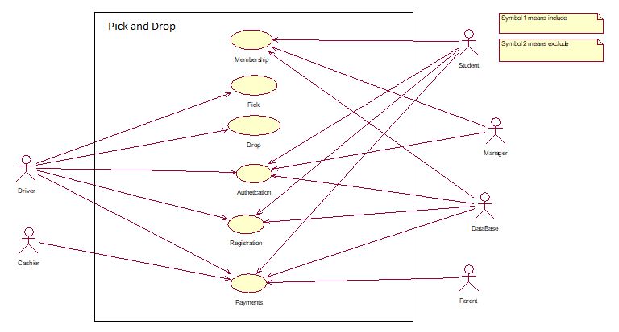

**Analysis Level**

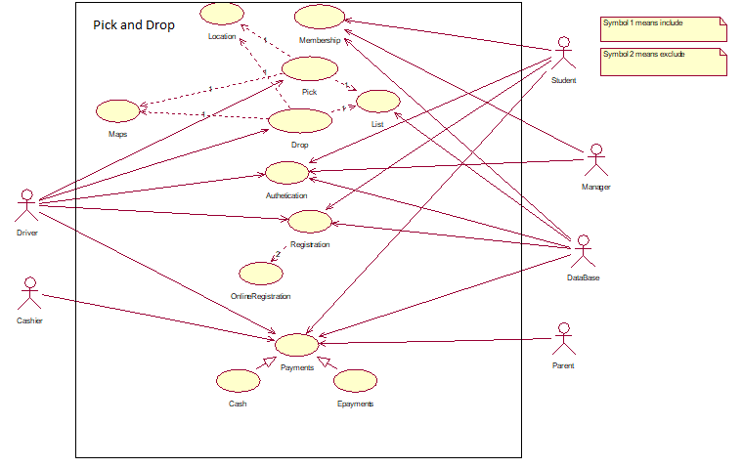

**USE CASE 1**

**Use Case Name:**

Registering a student

**Primary Actors:**

Parent , Student and Manager

**Stakeholders And Interest :**

1- **Parents** come and want to register the students into the system.

2- **Students** come with Parents and fill in their information on the registration form.

3- **Managers** receive registration forms and enter details into the system.

**Precondition:**

Students come , get registered and service should be available in her residential area.

**Success Guarantee:**

Students got a membership.

**Success Scenarios:**

* Students came to get register
* Students and Parents details are entered into the form by Manager
* Manager should make sure that the services are available in that resident.
* Services are available and successfully registered
* Student or Parent pay cash to Cashier
* Student got a membership card.
* Parents are provided with the car info.

**Alternate Scenarios:**

* Service site area range is not managed by the company.
* Service is available but drivers Cab’s slot is not available.

**USE CASE 2**

**Use Case Name:**

Picking a Student

**Primary Actors:**

Parent , Student and driver.

**Stakeholders And Interest :**

1- **Parents** make sure that their child goes in the right car.

2- **A student** rides in the right car**.**

3- **Driver** picks up the student from the provided address.

**Precondition:**

Student is ready to be picked up and the driver arrives on time to pick her up.

**Success Guarantee:**

Students got picked up at the right time.

**Success Scenarios:**

* Students are ready at pickup time.
* Driver arrives at the location at a given time.
* Parents should make sure that students get in the right car.

**Alternate Scenarios:**

* Student is late.
* Driver is absent or he does not arrive on time.
* Parents do not recognize the number plate of the cab on which their child is getting on.
* Parents do not recognize drivers.

**USE CASE 3**

**Use Case Name:**

Dropping a Student

**Primary Actors:**

Student and driver.

**Stakeholders And Interest :**

1- **Drivers** drop off the student to their destination address.

2- **Students** dropped off the car at their location.

**Precondition:**

Driver should make sure that he is dropping students to their desired address one by one.

**Success Guarantee:**

Students got dropped off at their location.

**Success Scenarios:**

* Students are ready to be dropped on their desired address.
* Drivers drop students on their address..

**Alternate Scenarios:**

* Students can’t reach their addresses on time because of some crises and road blockage.

**Activities Diagrams**

**Registration**

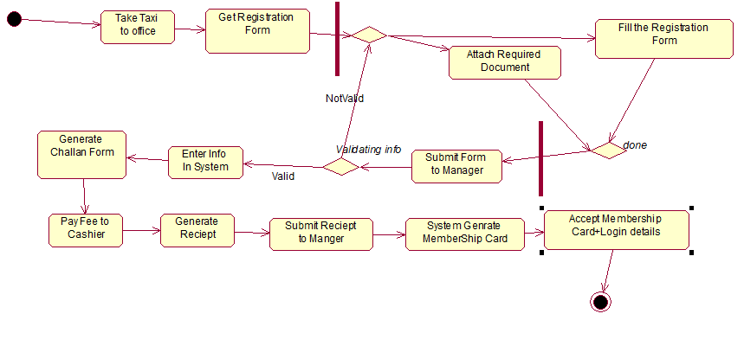

**Pick Up**

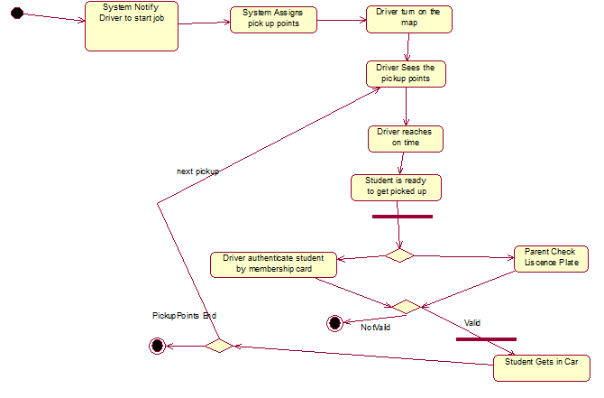

**Drop off**

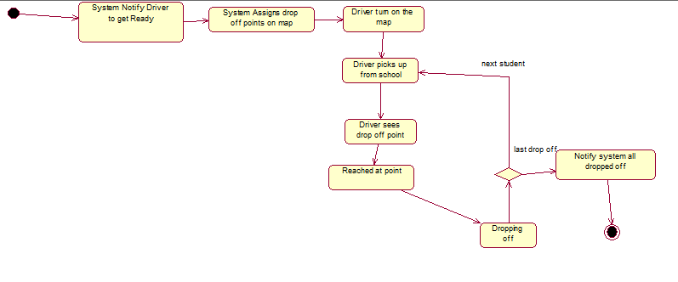

**SwimLane Activity Diagrams**

**Registration**

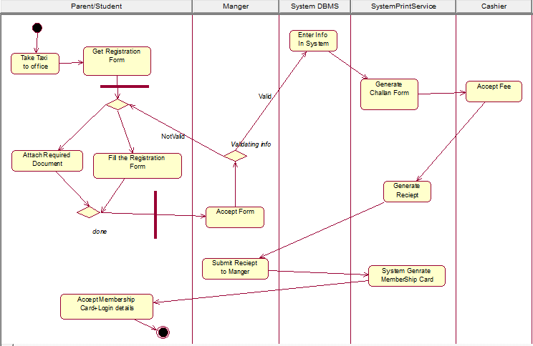

**Pickup**

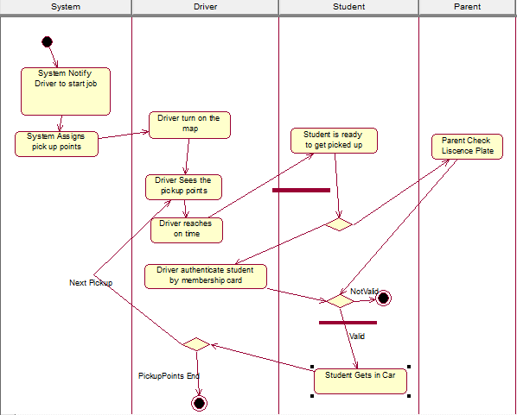

**Drop Off**

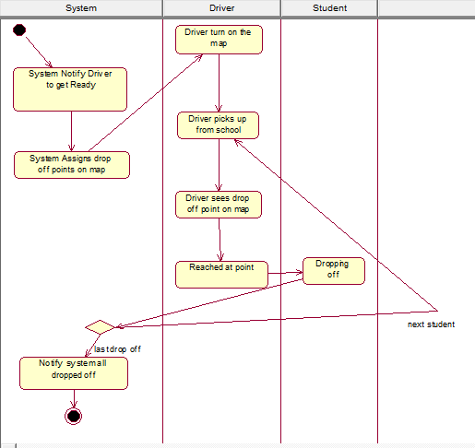

**StateChartDiagrams**

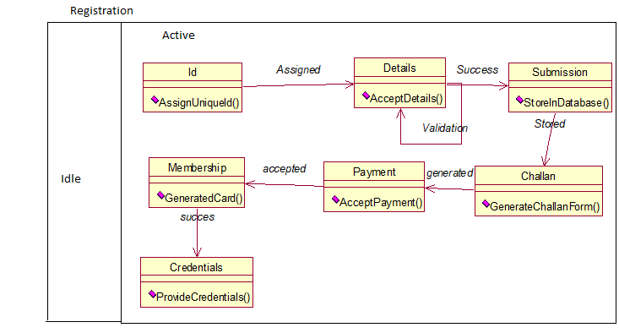

**Pick**

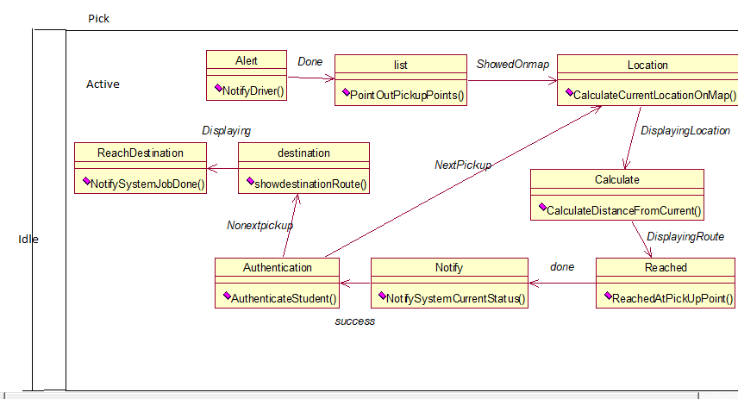

**Drop**

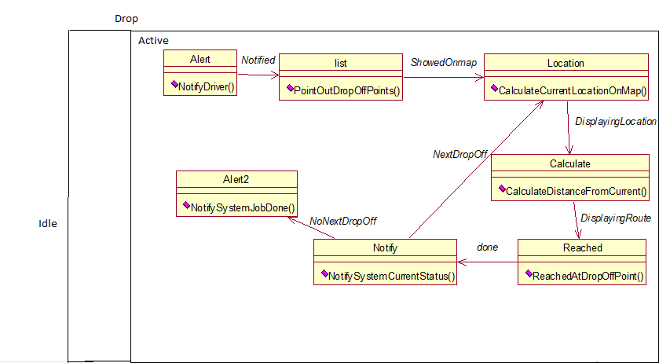

**Package Diagram**

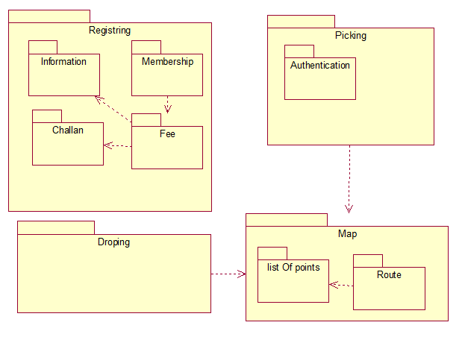

**Glossary**

**Term Definition**

1-RFID Radio Frequency Identification

2-PDMS Pick and Drop Management System

3-C# Programming Language (object oriented)

4-SQL Structured Query language (for database)